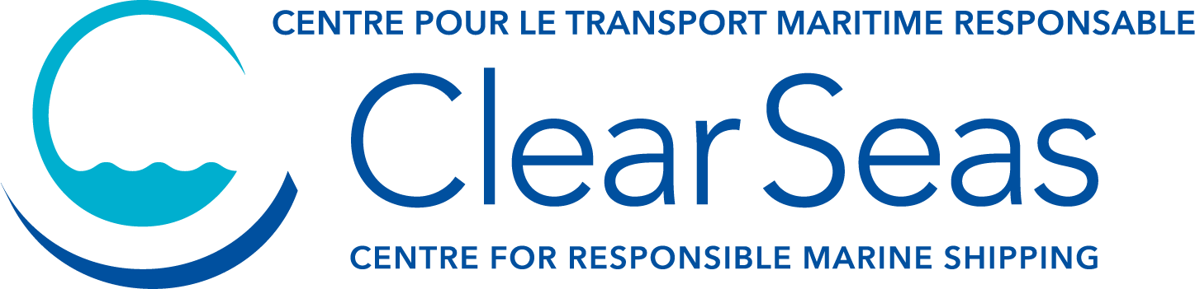

Indigenous Career Pivot Program
The Indigenous Career Pivot Program promotes workplace inclusion and diversity across ocean-related industries by providing Indigenous Peoples with the opportunity to explore new career paths in safe and supportive work environments. The program also enhances the cultural competencies of participating organizations by providing them with valuable tools to attract and retain talent.
The hiring organizations selected as part of the program are expected to offer employment to their candidates for the 12-month period of the contract, and to:
- Establish an onboarding, orientation, and continued support plan for the employee
- Allow the employee to participate in career development workshops and support activities
- Assign a mentor to the employee within their organization
- Participate in Canada’s Ocean Supercluster’s Intercultural Competency Training
- Provide quarterly updates and submit a final report upon completion of the contract
Employer Application Form
Please download, fill, and send your form by email to ICPP@clearseas.org once completed.

PART 1 – Applicant Information
IDENTIFICATION
Organization Name |  | Organization Type (non-profit, corporation, etc.)
CRA Business Number |  | OSC Member Status | Number of Employees
Organization Address

City or Town | Province or Territory | Country (if not Canada) | Postal Code
Telephone Ext. | Email Address

CONTACT Primary contact in respect to this application
Name |  | Surname
Position Title |  | Preferred Language of Communication (EN/FR)
Address (if different from Organization Address)

City or Town | Province or Territory | Country (if not Canada) | Postal Code
Telephone Ext. | Email Address

PART 2 – Placement Position
Position Details
Position Title | Salary (per annum)
Workplace Location | Workplace Environment (office, field, Covid-19 accommodations)
Will this position fulfill a role within a current or anticipated OSC Technology Leadership or Innovation Ecosystem project? If yes, provide details of project and role.

Mandatory Pre-employment Qualifications
List any qualifications that are prerequisite to the position (examples would include ArcGIS, Sage300, Class 3 Driver’s License, GTAW Welding)

Preferred Competencies
List any skillset that would be beneficial to the position (examples would include computer network administration, technical writing, bookkeeping, confined space training, Bilingual)
Job Profile
Please provide a full description of the placement position including an overview of your company and the role, position duties and responsibilities, qualifications, and abilities) (max. 1,000 words)

PART 3 – Employer Information
Outcomes
Please provide a summary of the role this placement position would play in your company, the importance of leveraging the Indigenous Career Pivot Program and anticipated outcomes beyond project completion (max. 1,000 words)

PART 4 – Preferred Candidates
Please indicate one or more employee candidates that you would like to consider for this position. These candidates will be contacted by Clear Seas to reconfirm their availability and you will then be provided an opportunity to interview for the position.
Interviewees
Candidate 1
Candidate 2
Candidate 3
Candidate 4
Candidate 5

